Practical-1
TASK-1:
Compilation and Execution:
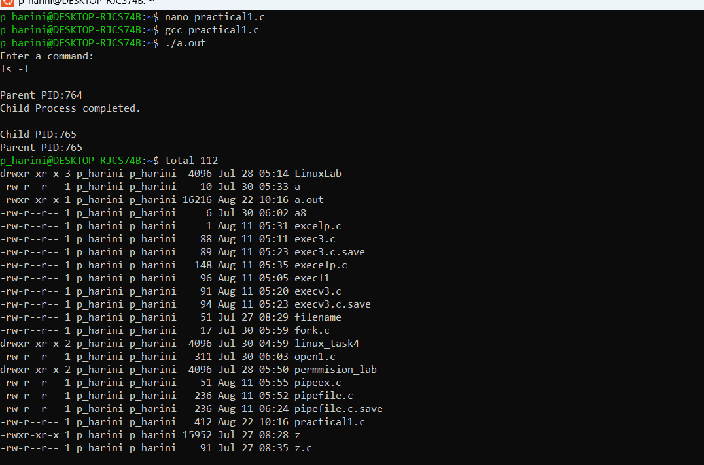
TASK 2:
1.uname:
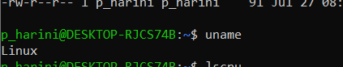
2.lscpu:
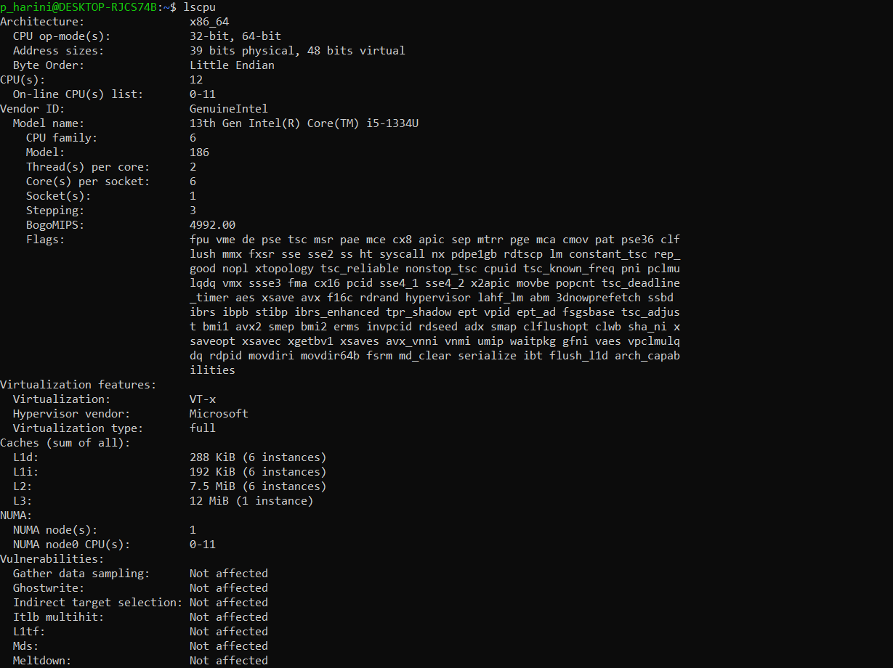

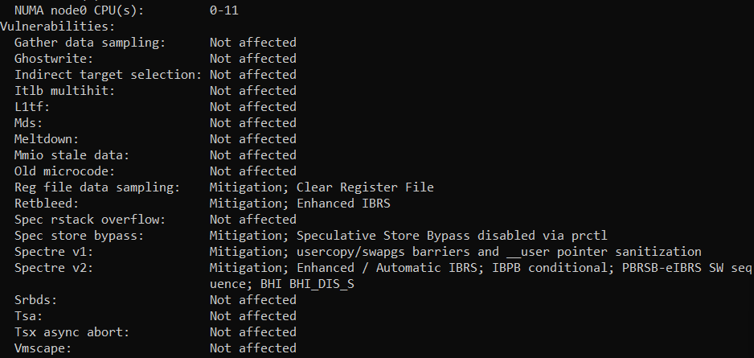
3.lsblk:
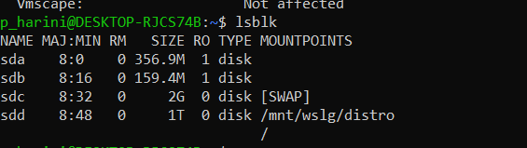

4.ps:
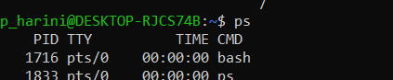
5.top:
